**CS 422 – Data Mining**

Homework 4

**25 April 2017**

Mayank Bansal

A20392482

**Recitation Problems**

**Problem 9.2.1**

$$cosine\left(A,B\right)=\frac{\left(8.2008 + 160000α^{2}+ 24β^{2}\right)}{\sqrt{9.3636 + 250000α^{2}+ 36β^{2}}\sqrt{7.1824 + 102400α^{2}+ 16β^{2}}}$$

$$cosine\left(B, C\right)=\frac{\left(7.8256 + 204800α^{2}+ 24β^{2}\right)}{\sqrt{7.1824 + 102400α^{2}+ 16β^{2}}\sqrt{8.5264 + 409600α^{2}+ 36β^{2}}}$$

$$cosine\left(A, C\right)=\frac{8.9352 + 320000α^{2}+ 36β^{2}}{\sqrt{9.3636 + 250000α^{2}+ 36β^{2}}\sqrt{8.5264 + 409600α^{2}+ 36β^{2}}}$$

$$θ_{A,B}=\cos^{-1}\left(\frac{8.2008 + 160000+ 24}{\sqrt{9.3636 + 250000+ 36}\sqrt{7.1824 + 102400+ 16}}\right) =0.1323$$

$$θ_{B,C}=\cos^{-1}\left(\frac{7.8256 + 204800+ 24}{\sqrt{7.1824 + 102400+ 16 }\sqrt{8.5264 + 409600+ 36}}\right)=0.2824$$

$$θ_{A,C}=\cos^{-1}\left(\frac{8.9352 + 320000+ 36}{\sqrt{9.3636 + 250000+ 36}\sqrt{8.5264 + 409600+ 36}}\right)=0.1748$$

$$θ_{A,B}=\cos^{-1}\left(\frac{8.2008 + 160000{\left(0.01\right)}^{2}+ 24{\left(0.5\right)}^{2}}{\sqrt{9.3636 + 250000{\left(0.01\right)}^{2}+ 36{\left(0.5\right)}^{2}}\sqrt{7.1824 + 102400{\left(0.01\right)}^{2}+ 16{\left(0.5\right)}^{2}}}\right) =7.7433$$

$$θ_{B,C}=\cos^{-1}\left(\frac{7.8256 + 204800{\left(0.01\right)}^{2}+ 24{\left(0.5\right)}^{2}}{\sqrt{7.1824 + 102400{\left(0.01\right)}^{2}+ 16{\left(0.5\right)}^{2} }\sqrt{8.5264 + 409600{\left(0.01\right)}^{2}+ 36{\left(0.5\right)}^{2}}}\right)=14.2623$$

$$θ_{A,C}=\cos^{-1}\left(\frac{8.9352 + 320000{\left(0.01\right)}^{2}+ 36{\left(0.5\right)}^{2}}{\sqrt{9.3636 + 250000{\left(0.01\right)}^{2}+ 36{\left(0.5\right)}^{2}}\sqrt{8.5264 + 409600{\left(0.01\right)}^{2}+ 36{\left(0.5\right)}^{2}}}\right)=7.4516$$

$$Average Disk Size=\frac{500+320+640}{3}=\frac{1460}{3}$$

$$→α=\frac{3}{1460}=0.002$$

$$Average Main-Memory Size=\frac{6+4+6}{3}=\frac{16}{3}$$

$$→β=\frac{3}{16}=0.1875$$

$$θ_{A,B}=\cos^{-1}\left(\frac{8.2008 + 160000{\left(0.002\right)}^{2}+ 24{\left(0.1875\right)}^{2}}{\sqrt{9.3636 + 250000{\left(0.002\right)}^{2}+ 36{\left(0.1875\right)}^{2}}\sqrt{7.1824 + 102400{\left(0.002\right)}^{2}+ 16{\left(0.1875\right)}^{2}}}\right) = 6.011$$

$$θ_{B,C}=\cos^{-1}\left(\frac{7.8256 + 204800{\left(0.002\right)}^{2}+ 24{\left(0.5\right)}^{2}}{\sqrt{7.1824 + 102400{\left(0.002\right)}^{2}+ 16{\left(0.1875\right)}^{2} }\sqrt{8.5264 + 409600{\left(0.002\right)}^{2}+ 36{\left(0.1875\right)}^{2}}}\right)=10.6385$$

$$θ_{A,C}=\cos^{-1}\left(\frac{8.9352 + 320000{\left(0.002\right)}^{2}+ 36{\left(0.5\right)}^{2}}{\sqrt{9.3636 + 250000{\left(0.002\right)}^{2}+ 36{\left(0.1875\right)}^{2}}\sqrt{8.5264 + 409600{\left(0.002\right)}^{2}+ 36{\left(0.1875\right)}^{2}}}\right)=5.2611$$

**Problem 9.2.3**

$$Average Rating =\frac{4+2+5}{3}=\frac{11}{3}$$

$$User A Rating: 4-\frac{11}{3}=\frac{1}{3}$$

$$User B Rating: 2-\frac{11}{3}=-\frac{5}{3}$$

$$User C Rating: 5-\frac{11}{3}=\frac{4}{3}$$

$$Processor Speed: 3.06 × \frac{1}{3}-2.68 ×\frac{5}{3}+2.92 ×\frac{4}{3}=0.4467$$

$$Disk Size: 500 × \frac{1}{3}-320 × \frac{5}{3}+640 × \frac{4}{3}= 486.6667$$

$$Main Memory Size: 6 × \frac{1}{3}-4 × \frac{5}{3}+6 × \frac{4}{3}=3.3333$$

**Problem 9.3.1**

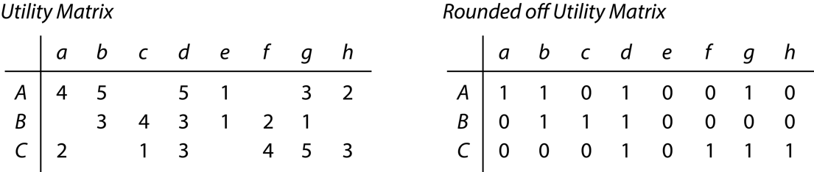

$$Jaccard\left(A, B\right)=\frac{4}{8}=\frac{1}{2}$$

$$Jaccard\left(B, C\right)=\frac{4}{8}=\frac{1}{2}$$

$$Jaccard\left(A, C\right)=\frac{4}{8}=\frac{1}{2}$$

$$cosDist\left(A, B\right)=1-\frac{1+1+1+1}{\sqrt{6}\sqrt{6}}=\frac{1}{3}$$

$$cosDist\left(B, C\right)=1-\frac{1+1+1+1}{\sqrt{6}\sqrt{6}}=\frac{1}{3}$$

$$cosDist\left(A, C\right)=1-\frac{1+1+1+1}{\sqrt{6}\sqrt{6}}=\frac{1}{3}$$

$$Jaccard\left(A, B\right)= \frac{3}{5}$$

$$Jaccard\left(B, C\right)= \frac{5}{6}$$

$$Jaccard\left(A, C\right)= \frac{4}{6}$$

$$cosDist\left(A, B\right)=1-\frac{2}{2\sqrt{3}}=0.422$$

$$cos\left(B, C\right)=1-\frac{1}{2\sqrt{3}}= 0.711$$

$$cos\left(A, C\right)=1-\frac{2}{2\sqrt{3}}=0.422$$

1. 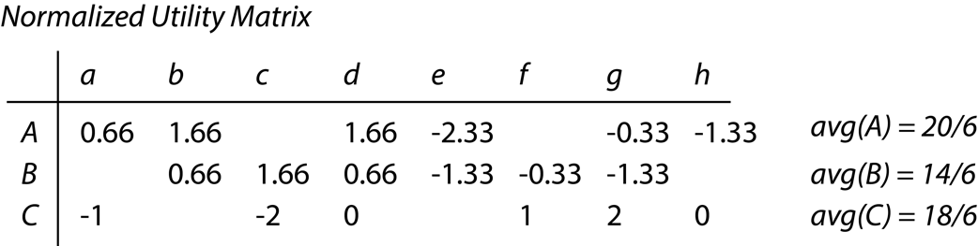

$$cosDist (A,B) = 1 – 0.58 = 0.42$$

$$cosDist (B,C) = 1 – 0.039 = 0.961$$

$$cosDist (C,A) = 1 - 0 = 1$$

**Problem 9.4.1**

$$M=\left[\begin{matrix}5 & 2 & 4 & 4 & 3 \\ 3 & 1 & 2 & 4 & 1 \\ 2 & & 3 & 1 & 4 \\ 2 & 5 & 4 & 3 & 5 \\ 4 & 4 & 5 & 4 & \end{matrix}\right]$$

$u_{32}$

From figure 9.10,

$$\left[\begin{matrix}1 & 1 \\ 1 & 1 \\ 1 & x \\ 1 & 1 \\ 1 & 1\end{matrix}\right]×\left[\begin{matrix}1 & 1 & 1 & 1 & 1 \\ 1 & 1 & 1 & 1 & 1\end{matrix}\right]= \left[\begin{matrix}2 & 2 & 2 & 2 & 2 \\ 2 & 2 & 2 & 2 & 2 \\ 1+x & 1+x & 1+x & 1+x & 1+x \\ 2 & 2 & 2 & 2 & 2 \\ 2 & 2 & 2 & 2 & 2\end{matrix}\right]$$

Sum of squares from the 3rd row:

$f\left(x\right)={\left(2-(x+ 1)\right)}^{2}+0+ {\left(3-(x+ 1)\right)}^{2}+({1-(x+1))}^{2}+ {\left(4-(x – 3)\right)}^{2}$

To find minimum value of $f\left(x\right)$:

$$\frac{d\left(f\left(x\right)\right)}{d\left(x\right)}=0$$

$$\frac{d\left(f\left(x\right)\right)}{d\left(x\right)}=-2\left(x-1\right)-2\left(x-2\right)-2\left(x\right)-2\left(x-3\right)=0$$

Solving for $x$,

$$x=\frac{3}{2}$$

Substituting $x$,

$$\left[\begin{matrix}1 & 1 \\ 1 & 1 \\ 1 & 1.5 \\ 1 & 1 \\ 1 & 1\end{matrix}\right]×\left[\begin{matrix}1 & 1 & 1 & 1 & 1 \\ 1 & 1 & 1 & 1 & 1\end{matrix}\right]= \left[\begin{matrix}2 & 2 & 2 & 2 & 2 \\ 2 & 2 & 2 & 2 & 2 \\ 2.5 & 2.5 & 2.5 & 2.5 & 2.5 \\ 2 & 2 & 2 & 2 & 2 \\ 2 & 2 & 2 & 2 & 2\end{matrix}\right]$$

$v_{14}$

From figure 9.10,

$$\left[\begin{matrix}1 & 1 \\ 1 & 1 \\ 1 & 1 \\ 1 & 1 \\ 1 & 1\end{matrix}\right]×\left[\begin{matrix}1 & 1 & 1 & y & 1 \\ 1 & 1 & 1 & 1 & 1\end{matrix}\right]= \left[\begin{matrix}2 & 2 & 2 & y+1 & 2 \\ 2 & 2 & 2 & y+1 & 2 \\ 2 & 2 & 2 & y+1 & 2 \\ 2 & 2 & 2 & y+1 & 2 \\ 2 & 2 & 2 & y+1 & 2\end{matrix}\right]$$

Sum of squares from the 4th column:

$$f\left(y\right)={\left(4-(y+ 1)\right)}^{2}+ {\left(4-(y+1\right))}^{2}+ {(1-\left(y+1\right))}^{2}+ {\left(3-(y+ 1)\right)}^{2}+ {\left(4-(y+ 1)\right)}^{2}$$

To find minimum value of $f\left(y\right)$:

$$\frac{d\left(f\left(y\right)\right)}{d\left(y\right)}=0$$

$$\frac{d\left(f\left(y\right)\right)}{d\left(y\right)}=-2\left(y-3\right)-2\left(y-3\right)-2y-2\left(y-2\right)-2(y-3)=0$$

Solving for $y$,

$$y=\frac{11}{5}$$

Substituting $y$,

$$\left[\begin{matrix}1 & 1 \\ 1 & 1 \\ 1 & 1 \\ 1 & 1 \\ 1 & 1\end{matrix}\right]×\left[\begin{matrix}1 & 1 & 1 & 2.2 & 1 \\ 1 & 1 & 1 & 1 & 1\end{matrix}\right]= \left[\begin{matrix}2 & 2 & 2 & 3.2 & 2 \\ 2 & 2 & 2 & 3.2 & 2 \\ 2 & 2 & 2 & 3.2 & 2 \\ 2 & 2 & 2 & 3.2 & 2 \\ 2 & 2 & 2 & 3.2 & 2\end{matrix}\right]$$

**Practicum Problems**

**Problem 2.1**

Cosine Similarity (user-200, movie-95) = 0.3875

Cosine Distance (user-200, movie-95) = 0.6125

Cosine Similarity (user-15, movie-95) = 0.2151

Cosine Distance (user-15, movie-95) = 0.7849

The system is more likely to recommend movie 95 to user 200.

**Problem 2.2**

Expected rating for the item for user 1 is 4.0